Project Design Phase-II
Data Flow Diagram & User Stories

Date | 11 September 2026
Team ID | NA
Project Name | Metro Ticket Generating System in ServiceNow
Maximum Marks | 4 Marks

Data Flow Diagrams:
- Commuter navigates to the Service Portal (/sp) and opens the "Book A Metro Ticket" catalog item.
- Form reads the station master list from the database table (u_metro_station_details).
- Commuter inputs origin, destination, journey type, and passenger count; an onChange client script calculates fares dynamically.
- If "Others" is selected under payment mode, a UI Policy dynamically displays and mandates the alternate payment field.
- On checkout, an onSubmit client script intercepts form submission, queries the QR generation API, and renders an interactive spModal popup containing a 250x250 scannable digital entry pass.
- Once the commuter confirms the modal, the transaction generates backend ServiceNow fulfillment records (sc_request and sc_req_item).
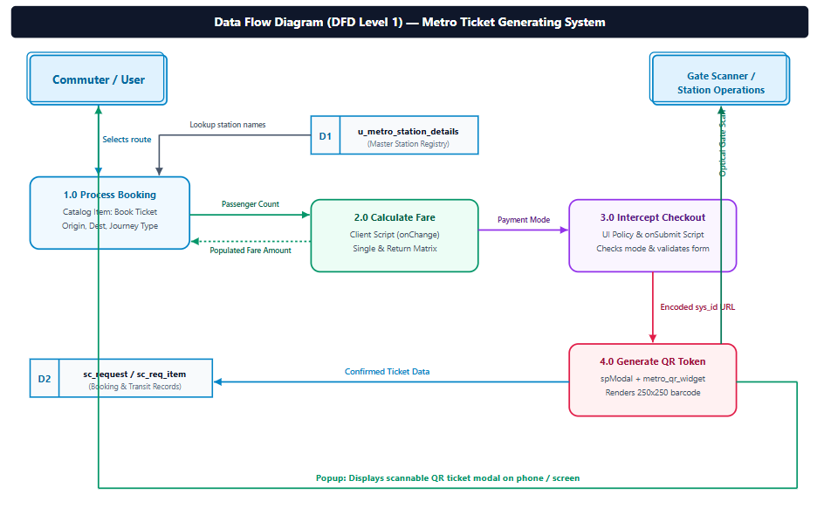
User Stories

User Type | Functional Requirement (Epic) | User Story Number | User Story / Task | Acceptance criteria | Priority | Release
Customer (Mobile user) | Route Selection | USN-1 | As a commuter on mobile, I can select my source and destination stations using reference lookups so that I can choose accurate travel stops. | Stations populate from the u_metro_station_details table without manual text input. | High | Sprint-1
Customer (Mobile user) | Fare Automation | USN-2 | As a commuter, I want my journey fare calculated automatically when I pick stations and passenger counts so that I see exact ticket prices. | Fare updates immediately via an onChange client script based on Single (1) or Return (2) journeys. | High | Sprint-1
Customer (Mobile user) | Digital Ticketing | USN-3 | As a commuter, I want an instant QR ticket rendered in an on-screen modal upon checkout so that I can proceed directly to gate entry. | An spModal popup appears rendering a scannable 250x250 QR code encoded with a unique ticket identifier. | High | Sprint-1
Customer (Mobile user) | Flexible Payment | USN-4 | As a commuter selecting "Others" as my payment mode, I want an additional input field so that I can specify my alternate payment provider. | UI Policy displays enter_payment_mode and enforces it as mandatory when mode_of_payment is set to "Others". | Medium | Sprint-1
Customer (Web user) | Portal Booking | USN-5 | As a web user on desktop, I can book tickets through the Service Portal (/sp) catalog so that I can plan trips in advance from my computer. | Booking item renders responsively on the desktop portal with full variable support and checkout confirmation. | High | Sprint-1
Customer (Web user) | Return Journey Support | USN-6 | As a web user, I can choose a return journey so that my ticket covers round trips without booking twice. | System automatically calculates and populates the return trip fare within amount_including_return. | High | Sprint-1
Customer Care Executive | Order Tracking | USN-7 | As a support executive, I can track passenger booking requests via REQ and RITM records so that I can resolve commuter queries. | Generated sc_req_item records display station variables, ticket amounts, and journey types accurately. | Medium | Sprint-2
Administrator | Station Master CRUD | USN-8 | As an admin, I can create, update, and manage stations in u_metro_station_details so that the station registry remains up to date. | Station admin role can manage records; updates reflect immediately in catalog station lookups. | High | Sprint-1
Administrator | Data Security & ACLs | USN-9 | As an admin, I want role-based ACLs configured so that public portal commuters can read stations but cannot alter station database tables. | Table-level ACLs enforce read permissions for end users while restricting write/delete actions to metro_admin. | High | Sprint-1
Administrator | Fare Matrix Maintenance | USN-10 | As an admin, I want to modify station fare pricing rules in the script so that ticket rates can be updated when metro policies change. | Fare conditions in client scripts can be adjusted with updated pricing rules without disrupting portal services. | Medium | Sprint-2

